Intelligent Accident Detection and Alert System using Machine Learning

Arpita
Dept. Of CSE
Dayananda Sagar University
Harohalli, India
balkundearpita@gmail.com

Bhuvana A M
Dept. Of CSE
Dayananda Sagar University
Harohalli, India
bhuvanaam76@gmail.com
Dr. Shreekanta Salotagi
Dept. Of CSE
Dayananda Sagar University
Harohalli, India
Darshini R
Dept. Of CSE
Dayananda Sagar University
Harohalli, India
darshinir762@gmail.com

Abstract—Road accidents in India frequently cause fatalities owing to delayed rescue operations, unavailable ambulances, and heavy traffic on the road. Hence, this study outlines the creation of a novel method for detecting road accidents using artificial intelligence. In this study, the data collected from the GPS and live camera images were analyzed using deep learning, whereby a convolutional neural network model was designed according to the requirements of the problem. Furthermore, four other pre-trained models – VGG16, ResNet50, MobileNetV2, and EfficientNetB0 – were deployed using transfer learning techniques. The proposed system will automatically notify the concerned parties upon detecting any road accident through the software, along with providing the geographical location.
Keywords—Deep Learning, Convolution Neural Networks, Image Classification,Transfer Learning, Model Evaluation.

I.Introduction

Over the last several years, the progress in Deep Learning led to the achievement of high success in terms of enhancing the performance of image classification and pattern recognition systems. Amongst various methods that have been developed recently, CNNs have gained special attention because of their ability to extract features hierarchically from the input image. The mentioned architecture found its application in multiple spheres such as medicine, autonomous driving, or intelligent video surveillance. Yet, there are several requirements that should be met before the model is applied successfully.
Some complex neural network structures using transfer learning methodology have been proposed in order to address these issues. Some of the pretrained models that exist are VGG16, ResNet50, MobileNetV2, and EfficientNetB0. These models rely on the large number of examples in ImageNet to learn the features, minimizing reliance on large amounts of training data and the associated computational costs. While the focus of VGG16 lies in building a deep model, ResNet50 addresses the problem of vanishing gradients with its residual connections. MobileNetV2 is specifically designed to be computation-friendly.
In this research, an evaluation analysis is carried out on the basis of comparing the performance of a customized CNN and the various pre-trained networks in terms of their performance on the given dataset. Evaluation of performance will be done using evaluation measures such as accuracy, precision, recall, and F1 measure, and other methods such as performance graphs and probability distributions. The purpose of carrying out the comparison exercise is to identify the most efficient model in terms of accuracy, efficiency, and generalization.

II.LITERATURE REVIEW

Several studies have suggested a number of remedies using classical machine learning techniques which are inefficient. Some of the solutions are mentioned below.

The above-mentioned system works on the basis of hardware, where if the user drinks more than his limit, the system automatically stops the engine if any vibration is detected. If there are changes in the analyzed data, then an alert message is sent to ensure the safety of the driver by keeping him in safety mode for around thirty seconds, then the driver needs to press the button or else an alert message will be sent to emergency services [1].

The purpose of this system is to observe continuously where the face of the driver will be monitored when the car starts and the blinkings of eyes are being monitored in order to detect whether the driver falls asleep or not. If the system detects any change in the analyzed data, it will send contact information to hospitals, police station and other emergency services [2].

The design of a system that will be able to detect accidents in real time by analyzing live CCTV camera footage. This device will analyze the environment and once it identifies anything that looks questionable, the system will then determine if an accident has taken place using imagery [3].

Design of a system that will take inputs from the driver in terms of weather, nature of the road, vehicle speed, and lighting conditions, after which the device will inform the driver if the road conditions are favorable or not, in addition to predicting possible accidents [4].

The system uses sensors which will continuously monitor the environmental data and relay it to the microcontroller which then analyzes the data and determines if there is an accident occurring. Once this is determined, the local alarm will be set off, and the data will be sent to the Raspberry Pi which will send out the data through WiFi to the cloud for analysis by the machine learning model. If any emergencies arise, the device will alert the driver and send out the data to rescue teams via cell phone [5]

The system works by initially feeding it a video which it breaks down into frames that are then checked for the presence of features that can help in object recognition. The frames are subjected to a detection algorithm like YOLO which is used to analyze the video to find out if there was an accident. This procedure has already been tested through training and testing on annotated data. Once the accident is detected, the program notifies the administrator of the event together with pictures and the number of injuries alongside storing the data in a database [6].

In this case, both the video frame and optical flow become the inputs to the ConvLSTM layers that help in extracting the spatial and temporal characteristics. After convolution of the inputs, there is a batch normalization of the data, and GAP is done in order to make the inputs smaller. Then the generated outputs are further made smaller in order to get the RGB and motion features, which will be helpful in determining what kind of activity is going on in the video[7].

All this is done based on the principles of operation of the car tracking system and warning system. First, the entire system is initialized, and during this phase, the ARM microcontroller starts to take control over the entire system. Data acquisition takes place through the speed sensor, while the GPS module will provide location coordinates through UART communication. The obtained GPS data are processed by the microcontroller and then shown on the LCD display. Other necessary data are stored in the EEPROM memory. On the other hand, the GSM module is used to send data to an external destination or for sending SMS[8].

It too is akin to the IoT based surveillance system which uses MQTT protocol for transmitting the data. Firstly, data about motion and distances is captured by means of an accelerometer and ultrasonic sensor. After that, this data is sent to the ESP8266 Wi-Fi module. The ESP8266 will then send this data obtained from the sensor via LOSANT. There isn’t much that can be done with this data except for the purpose of triggering an alarm, creating a data visualization dashboard, executing many other processes including sending emails, and even subscribing ESP8266 to a certain topic and sending messages to it[9].

To perform any operation in the system, the video is divided into shots with the help of PySceneDetect. Further, the shots are divided into frames with the help of OpenCV. The selection of the key frames from the frame depends on the histogram difference and object distance estimation. In this way, only useful information is extracted. Further, the system performs feature extraction from the key frames with the help of ResNet50 architecture. These features are then classified with the help of K-Means Clustering, creating a “bag of visual words”. Finally, the data is divided into training and testing data, where SVM classification is performed for accident detection in the video [10].

The latest innovations in the field of deep learning include the improvement of image classification problems through the use of CNNs. The use of this particular method in machine learning was first proposed by Yann LeCun. It allows for automatic feature detection from images and makes it unnecessary for engineers to create handcrafted features in order for them to outperform other traditional machine learning methods. One other innovation in the area includes transfer learning using pre-trained deep learning models like VGG16, ResNet50, and MobileNetV2 to make use of information learned from large datasets like ImageNet [11].

III.PROPOSED SYSTEM
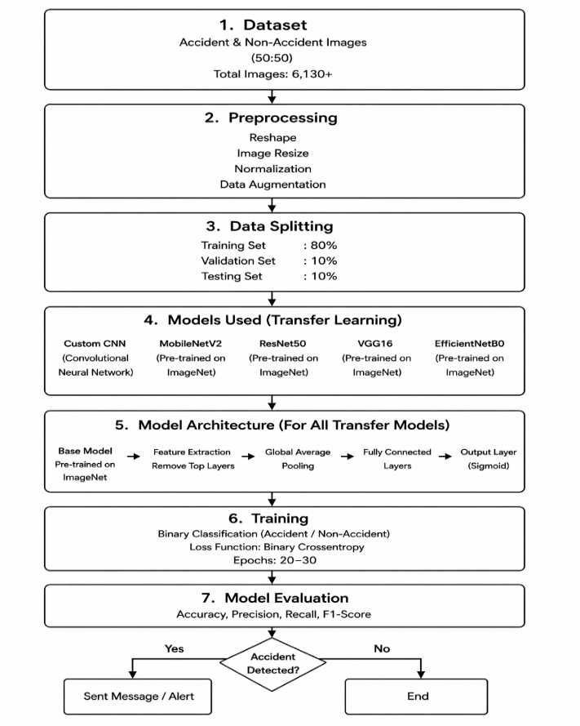
Fig.1. flow chart of accident detection and alert system

The proposed system will make use of deep learning techniques for the detection of road accidents through the use of images and sensor data. The technique of deep learning that will be utilized in the design of this particular project is the application of a Convolutional Neural Network (CNN) and pre-trained models in order to detect and notify authorities of the accident. Includes the following steps:
- Data collection
Data for the training of the models were gathered from various sources such as satellite images, CCTV and other surveillance devices, public data sets from sites like Kaggle, and even from simulated data through CARLA Simulator software. The aim of the data gathering process was to gather different scenarios in road traffic situations, thereby allowing the classification of the events as either accident or non-accident.
- Data Preprocessing

Image Pre-processing was done prior to training on the images in order to ensure uniformity and consistency.
Image Resizing:The process of resizing is done to prevent any mismatches between image sizes which would cause issues while training the model on the image.
Normalization:The process of normalization allows us to ensure that we are training our model more effectively and efficiently since it reduces the risk of encountering different large values.
Augmentation:The process of data augmentation helps in making the dataset larger artificially through the use of rotation, flips, zooms, or shifting images.
Reshaping:The process of reshaping ensures that the data is appropriately sized to allow the network to process the data.These steps standardize the input data and reduce computational complexity.

- Model development
Model development is a process through which the development of a system for categorizing road image data in the form of accidents or no accidents through the use of an advanced Convolutional Neural Network is carried out. The network uses convolution layers for learning features, pooling layers for reducing dimensions, and fully connected layers for making predictions. These predictions are made possible by the use of non-linear activations like ReLU and Sigmoid.
Moreover, pre-trained models such as VGG16, ResNet50, MobileNetV2, and EfficientNetB0 are implemented using Transfer Learning techniques. These pre-trained models learn features on large-scale datasets before being fine-tuned for our specific use case. Each model is trained using the Adam optimizer and binary cross entropy as the loss function.

Transfer Learning Implementation

The process of transfer learning is performed using deep learning algorithms that have already undergone training on a huge dataset such as the ImageNet dataset. The models are the VGG16, ResNet50, MobileNetV2, and EfficientNetB0. During the process of transfer learning, the last layers that are responsible for the classification part are removed, and new layers are added to facilitate the classification of accidents. The rest of the layers are frozen, apart from the new layers, in order to preserve the learnt features.

- Model Training

Training the model will involve the insertion of the preprocessed data into the customized CNN architecture alongside other pre-trained models such as VGG16, ResNet50, MobileNetV2, and EfficientNetB0. Training will be done via a number of epochs of the labeled data, where the Adam optimization algorithm will be used during training to minimize the binary cross-entropy loss function to achieve efficiency. Validation data will also be included in the training process. Transfer Learning will be implemented in the case of the pre-trained models by freezing the base layers and training the new layers.

- Accident detection

The process of detecting accidents takes place through the CNN algorithm, which is previously trained to detect an accident on the basis of the inputs that come in through the image and video form. After detecting an accident, the GPS location is automatically detected, and all related persons are informed regarding this accident.

- Nearest Hospital detection

In order to determine the closest hospital in relation to the accident point, the nearest hospital sensor uses a system called the Convolutional Neural Network to establish which of the closest hospitals is closer to the accident area.Through the Haversine formula, which uses the geographic locations of the GPS coordinate system, it calculates the distance from the accident area to the closest hospitals.When the nearest hospital is determined, the alarm will be raised.

For locating the nearest hospital, it calculates the distance between two locations using the latitude and longitude, in this way:

d=2r. arcsin$\text{( }\text{√}$(sin2(2Δϕ)+cos(ϕ1)cos(ϕ2)sin2(2Δλ))

- Alert generation System

Despite all that, when an accident occurs, the entire process becomes self-sufficient due to the application of the Convolutional Neural Network Model. The reason for that is the fact that through the application of the model, we can get crucial information, such as the location of the accident (with the aid of GPS) and the exact time the accident happened among others. Such information will be useful in informing people about potential accidents.

IV.RESULTS

In this section, performance analysis of the proposed CNN model is explained along with comparative analysis of other deep learning models. Techniques such as visualization techniques and performance evaluation metrics have been used to assess the efficiency, reliability, and robustness of the models.

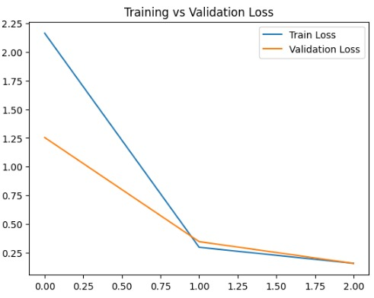
Fig.2. Training vs Validation Loss Graph

It can be observed from the chart Training and Validation Loss that there has been a consistent decline in the loss of both training and validation at every iterative level. It indicates that the learning capability of the model is adequate. In addition to this, since the decline in validation loss occurs after the decline in training loss, it implies that the generalization capability of the model is also adequate.

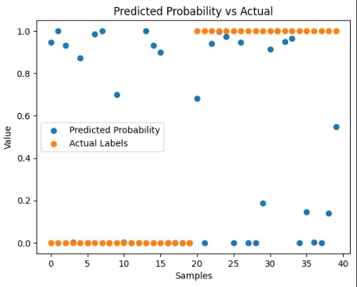
Fig.3 Predicted Probability vs Actual Value

This graph illustrates the probability score predictions compared to the actual class of each test instance. The majority of the blue dots are close to the actual classes, which suggests that the prediction done by the model has a high chance of accuracy.
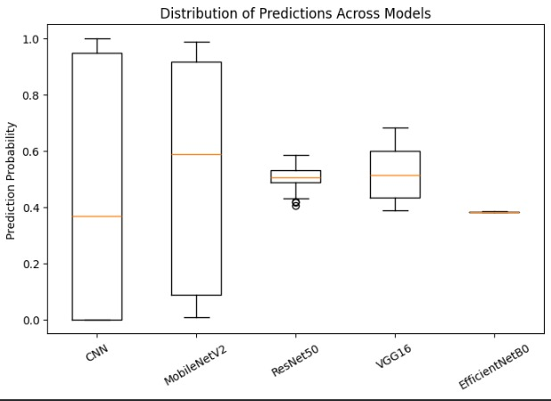

Fig.4. Distribution of Prediction Across Models

A box plot was used to illustrate the probability distribution of prediction of all the models.From the examination of the result, it becomes evident the level of certainty that the models have in making predictions. The closer the distribution of the models to zero and one, the more certain the models are about the predictions.On the other hand, if the distribution is wide, it shows that the models are not sure about the predictions. However, despite being a reflection of certainty, distributions cannot be considered as performance metrics of the models.

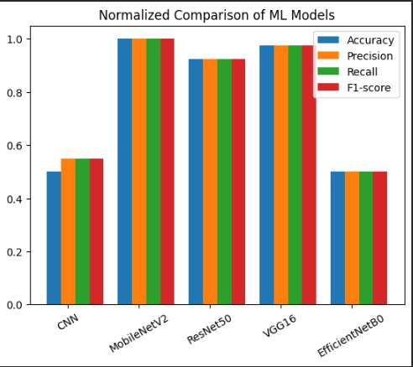

Fig.5. Normalized Comparison of ML Models

This plot depicts the relative performance of various machine learning algorithms based on their accuracy, precision, recall, and F1-score values. It enables us to distinguish which algorithm is superior by evaluating their performance against each other on a common scale. Based on the chart, the algorithms MobileNetV2 and VGG16 have high metric values, whereas CNN and EfficientNetB0 have low metric values.

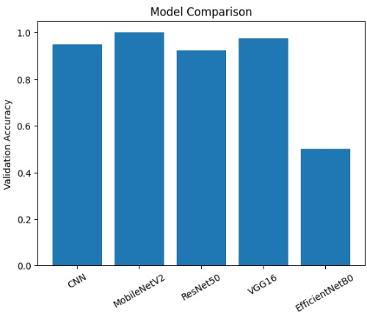

Fig.6. Model Accuracy Comparision graph

In order to validate the accuracy of different models such as CNN, MobileNetV2, ResNet50, VGG16 and EfficientNetB0, the bar chart was applied. It can be clearly seen from the obtained data that CNN model performs as efficiently as other pre-trained models.It can be seen from the analysis made above that even though the pre-trained models work excellently, the CNN model equally works very effectively in some cases. Nevertheless, it needs to be pointed out that the models were pre-trained according to their efficiency estimates.

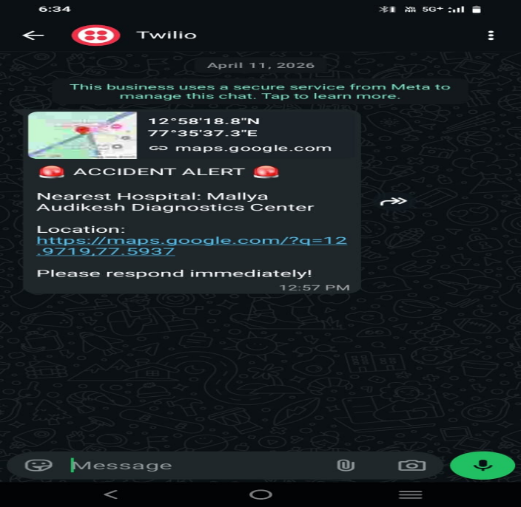

Fig.7. Emergency Alert Message

When an accident is detected by the system, an automatic emergency alert message is generated and sent to the nearest hospital using Twilio API.

Finally, this system has been used as a platform to come up with an accident detection system that could be incorporated into the alert system for hospitals and emergency service agencies. This will contribute to quicker responses during any accidents

V.CONCLUSION AND FUTURE WORK

The presented solution has effectively shown how deep learning algorithms, especially Convolutional Neural Network (CNN), can be used efficiently for prediction and classification purposes in the mentioned application area. Through proper training of the CNN on properly structured images and evaluation of its performance through different metrics, including accuracy, precision, recall, and F1-score, an efficient result was obtained. From the observation of the curves, it is evident that the CNN did not overfit during training and thus could generalize properly.
Apart from CNN, there are other models such as MobileNetV2, ResNet50, VGG16, and EfficientNetB0 that have been used for experimental purposes to determine their performance in conjunction with one another in different deep learning applications. Despite being applicable enough to compare one model against another, it was discovered that without proper training and pre-processing techniques, no comparison can be made at all. This is an aspect that should be considered because accuracy alone cannot provide an accurate comparison.
From the above analysis, it can be concluded that this study offers a great platform to create intelligent models through different approaches such as model evaluation approach, visualization approach, and comparison approach. With the help of different visualization techniques, such as accuracy graph, loss graph, residual graph, and prediction confidence graph, the results of the system have been interpreted more clearly. Therefore, the predictions made by the intelligent system become easy to interpret for the practical scenario.
The future developments that can be included in this project include widening the scope of the project by incorporating a smart system that would be able to detect any emergencies and recommend the nearest hospital in areas of least traffic. Such development can be done by using the GPS system and traffic information obtained from websites like Google maps and Waze. Simply put, the system would calculate all the available routes to the nearest hospital and then provide users with the best route.
Moreover, the system can also be programmed to send notifications along with the location of the accident, estimated time of arrival, and severity of the accident to the chosen hospital automatically. This will lead to an intelligent coordination process between the detection of the accident and the provision of healthcare facilities. By integrating deep learning algorithms, navigation, and Internet of Things technology, this project can become a completely automated system that will have a huge impact in the real world.

VI.REFERENCES
- G.Siri,G.Priyanka,B.Divya,G.Sameera,M.Pallavi, “Accident Detection and Alert System” IRJETS vol.04,Issue06,June-2022.
- Sinchana.RD,Sindhu.KS,Sudhakara.HM, “Accident Detection and Alert System for enhanced Safety and Response”, vol.13,Issue11,2024.
- Priyadarshini.C.patil,Padmanabhan Ghanate, Rishikesh patil, “Road Accident Detection and Alert Notification System using Machine Learning ”, IJSDR vol.10,Issue12, 2025.
- Devisha Arunadevi Tiwari,Emmadi Bhanu Sai,Bandapu Sai Chandu,”Machine Learning based Accident detection and Alert System” JEITR, May 2024.
- Gopal Sunil Rathod,Rani Chandrabhan Tipale,Dr. Kapil Jajulwar,”Intelligent Accident Detection and Alerting System based on Machine Learning over the IoT Network”2022 International Conference on Futuristic Technologies (INCOFT) Karnataka, India. Nov 25-27, IEEE 2022.
- Swapnali.R.Pawar,Rushikesh Bamne,Shreyash Patil,Sushant Chipate,Tanmay Vasagadekar,”Detection and Alert generation of road accident using Deep Learning”International Conference on Healthcare Innovations,Software and Engineering Technologies(HISET), IEEE 2024.
- VICTOR A. ADEWOPO,NELLY ELSAYED,”Smart City Transportation: Deep Learning Ensemble Approach for Traffic Accident Detection “,IEEE 2024.
- Pritam Banik Roy,Draksha,Ankika Dey,Rajendrani Mukherjee,Suparna Biswas,Suvamoy Changder,”Vehicle Tracking and Accident Prevention using Smart Technologies”,21st India Council International Conference (INDICON),IEEE 2024.
- Ravi K Kodali,Shubhi Sahu,”MQTT Based Vehicle Accident Detection and Alert System”,IEEE 2017.
- Aman Kumar Agrawal, Kadamb Agarwal, Jitendra Choudhary, Aradhita Bhattacharya, Srihitha Tangudu, Nishkarsh Makhija,Rajitha B,”Automatic Traffic Accident Detection System Using ResNet and SVM”,Fifth International Conference on Research in Computational.
- 11.Arnav Chaudhari, Harsh Agrawal, Smiti Poddar, Kiran Talele, Manisha Bansode "Smart Accident Detection And Alert System" IEEE India Council International Subsection Conference(INDISCON) 2021
Intelligence and Communication Networks (ICRCICN),IEEE 2020

